**राष्ट्रीय प्रौद्योगिकी संस्थान आंध्र प्रदेश**

**NATIONAL INSTITUTE OF TECHNOLOGY ANDHRA PRADESH**

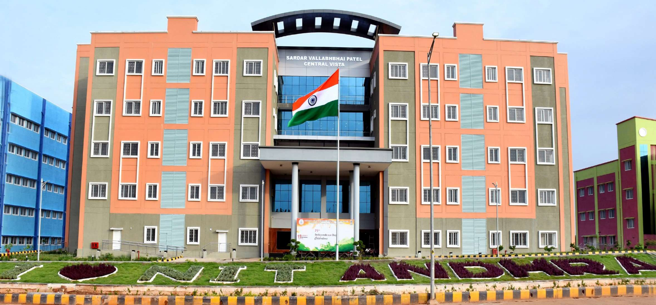

**Contact us:**

**Admissions office, NIT Andhra Pradesh**

**Phone no: 08818-235090, Mob: 9492743842, Email:** [**admissions@nitandhra.ac.in**](mailto:admissions@nitandhra.ac.in)**, ad_ar@nitandhra.ac.in.**

**Admission to M.Tech. Programme: 2025-26**

**Admission to M. Tech. programmes will be through the CMT 2025 (** [**www.ccmt.nic.in**](http://www.ccmt.nic.in) **) online system for centralized admission.**

# Eligibility:

**Eligibility Criteria will be as per norms of CCMT-2025**

**Campus Facilities:**

* Academic and administration buildings, equipped with interactive AC classrooms and recording provisions.
* Workshops and Laboratory Complexes
* Library
* Halls of residence, Faculty and Staff Quarters
* Guest House
* Students Activity Centers {both indoor and outdoor)
* Gymnasium
* Student amenities center
* Medical and Transport facilities
* Wi-fi and internet facilities.

**Accommodation:**

The Institute provides residential accommodation for all the UG and PG, girls and boys students inside campus premises.

**General Information:**

• Financial Aid {fellowship/scholarship/stipend) is available for the M.Tech. students as per MoE norms.

• All the registered candidates must reside in the campus.

• For more information regarding admission procedure and dates **please visit:** [**www.ccmtnic.in**](http://www.ccmtnic.in) **,** [**www.nitandhra.ac.in**](http://www.nitandhra.ac.in)

* Reservation shall apply as per Govt. of India rules.

|  |  |  |
| --- | --- | --- |
| **S. No.** | **Specialization** | **Department** |
| 1 | Bioprocess Engineering | Biotechnology |
| 2 | Chemical Engineering | Chemical Engineering |
| 3 | Geotechnical Engineering | Civil Engineering |
| 4 | Computer Science and Data Analytics | Computer Science and Engineering |
| 5 | Power Electronics & Drives | Electrical Engineering |
| 6 | Advanced Communication Systems & Signal Processing | Electronics and Communication Engineering |
| 7 | Thermal Engineering | Mechanical Engineering |
| 8 | Manufacturing Engineering |
| 9 | Materials Technology | Metallurgical & Materials Engineering |